Heaps 2

Heap Sort

Kth Largest Element

Kth Largest Element in every prefix

K sorted Array

Running Median

# Heap Sort

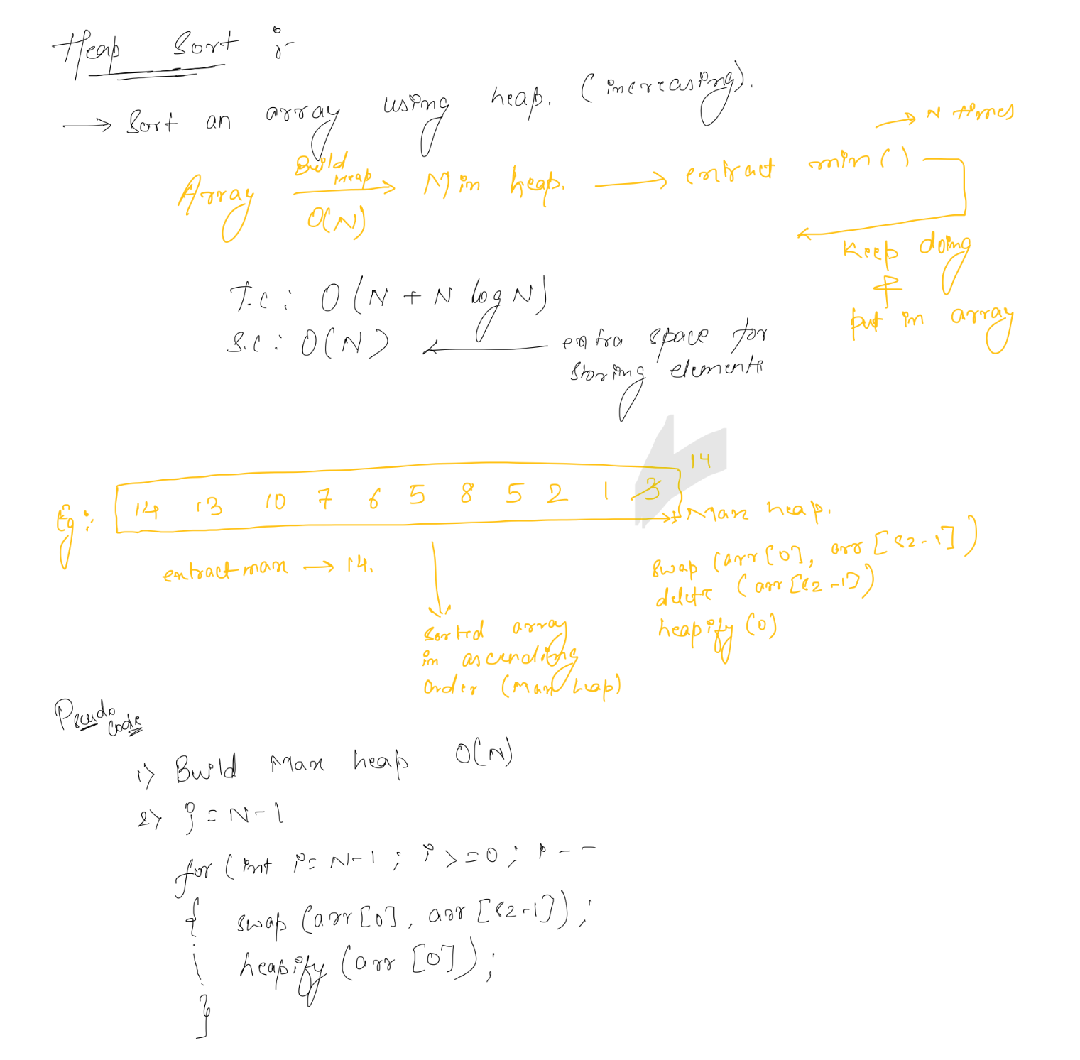

# Kth Largest Element

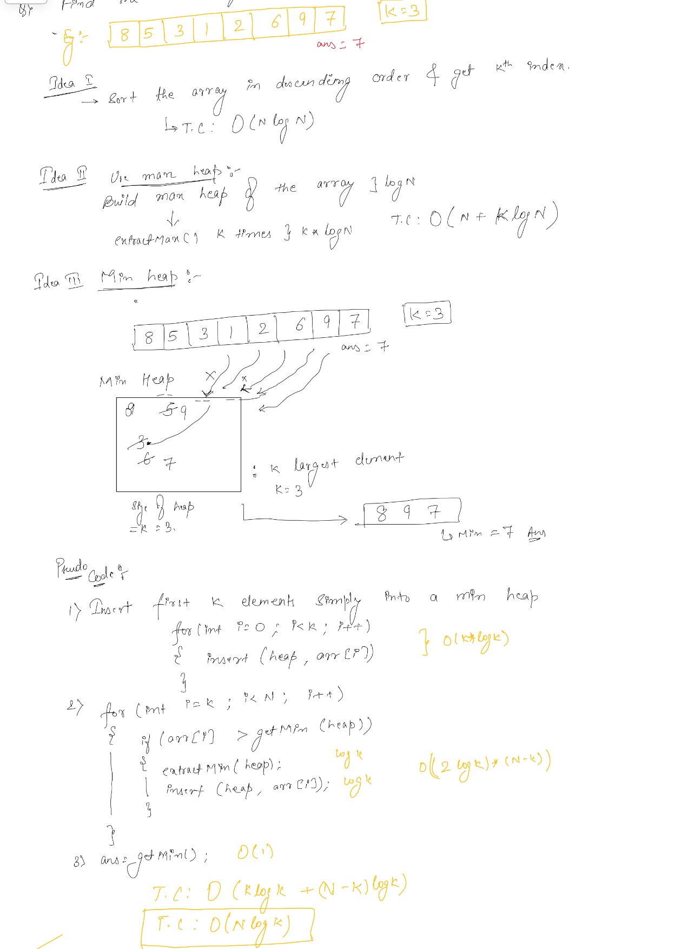

# Kth Largest Element in every prefix

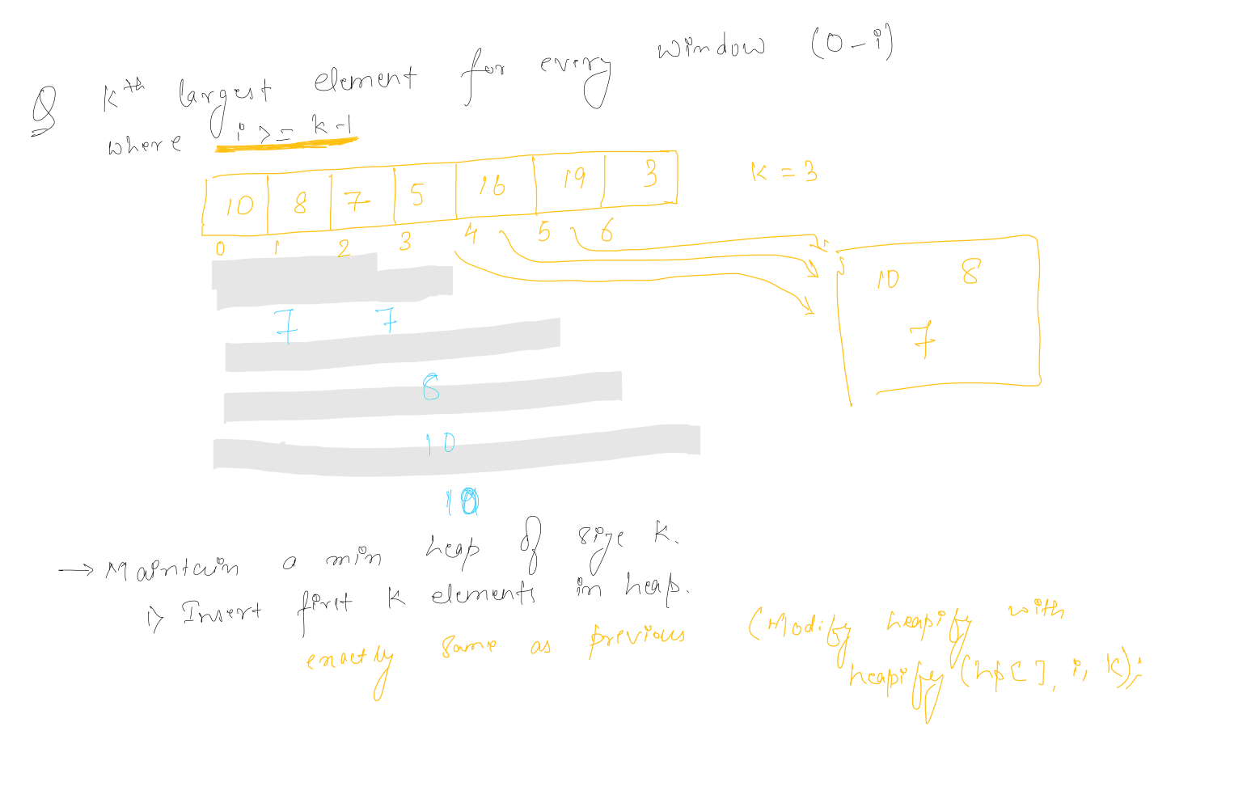

# K sorted Array

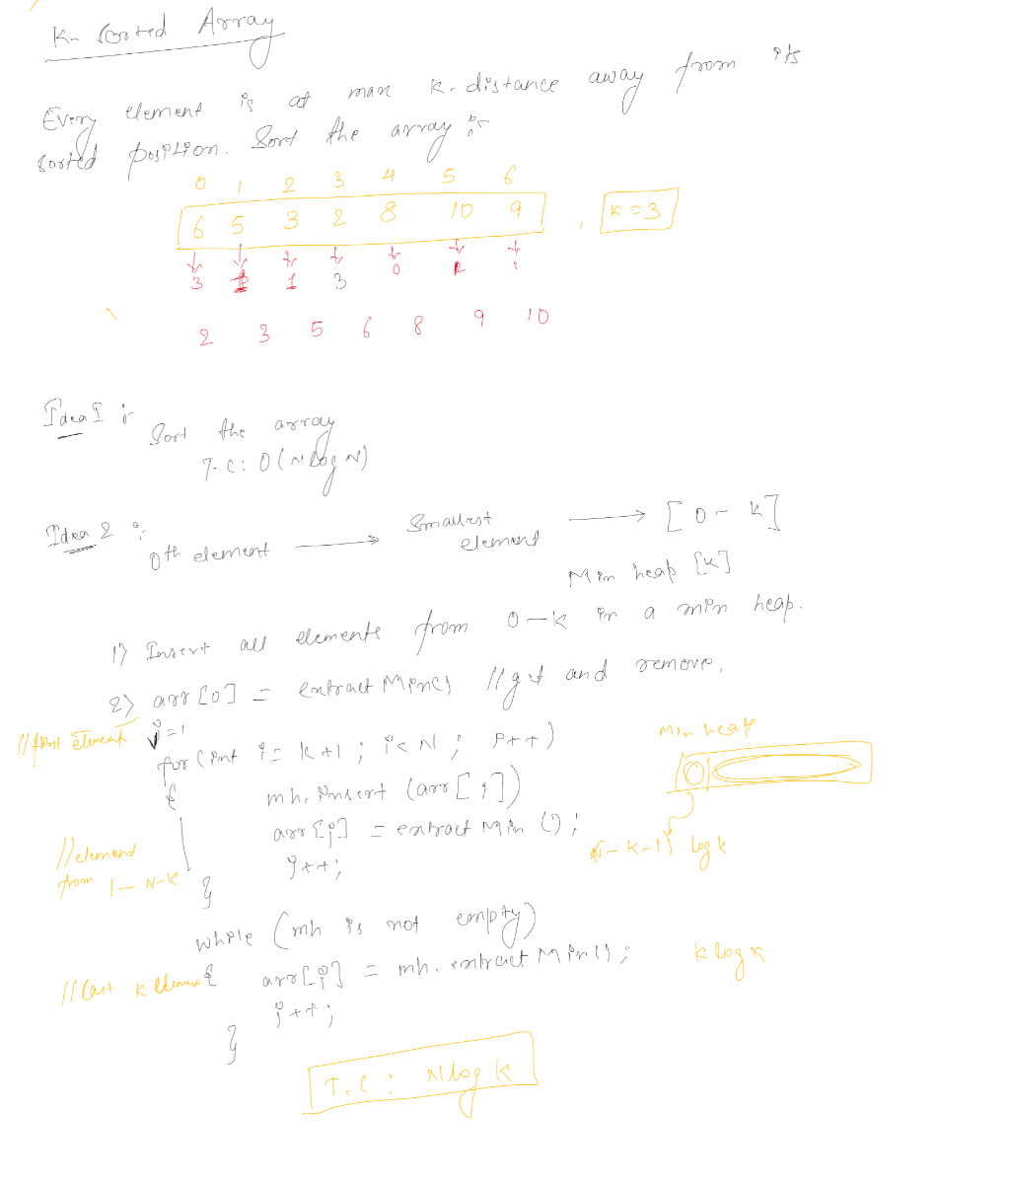

# Running Median

